

CS-110: Lab 11
Recursion

https://github.com/mmujtaba25/cs-110

Muhammad Mujtaba
CMD ID: 540040
mmujtaba.bese25seecs@seecs.edu.pk

  - Class: BESE 16B
  - Batch: 2k25

Task 1 [CLO 2]:

CODE:
#include <iostream>

int sumArray(const int arr[], int size)
{
// return if first element reached
if (size == 0)
return 0;

// add array from last element to first
return arr[size - 1] + sumArray(arr, size - 1);
}

int countOccurrences(const int arr[], int size, int element)
{
// return if first element reached
if (size == 0)
return 0;

int occurrence = (arr[size - 1] == element) ? 1 : 0;
return occurrence + countOccurrences(arr, size - 1, element);
}

int main()
{
constexpr size_t SIZE = 10;
int arr[SIZE]{0};

std::cout << "Enter " << SIZE << " integers:\n";

for (size_t i = 0; i < SIZE; ++i)
{
std::cin >> arr[i];
}

int element;
std::cout << "Enter an integer to count its occurrences: ";
std::cin >> element;

std::cout << "Sum of array elements: " << sumArray(arr, SIZE) << "\n";
std::cout << "Occurrences of " << element << ": " << countOccurrences(arr, SIZE, element) << "\n";

return 0;
}

OUTPUT:

Task 2 [CLO 2]:

CODE:
#include <iostream>

int sumDigits(int number)
{
// return if no digits left
if (number == 0)
return 0;

// add last digit; truncate last digit using int casting; call recursively
return (number % 10) + sumDigits(number / 10);
}

int main()
{
int number;
std::cout << "Enter a non-negative integer: ";
std::cin >> number;

std::cout << "Sum of digits: " << sumDigits(number) << "\n";

return 0;
}

OUTPUT:
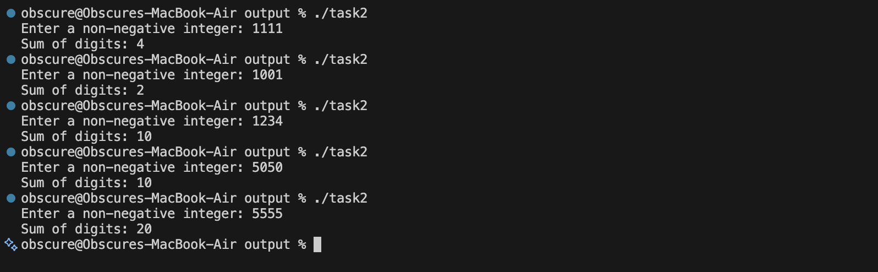

Task 3 [CLO 3]:

CODE:
#include <iostream>
#include <string>

bool checkPalindrome(const std::string &str, int left, int right)
{
// check if first and last is same
// repeat for next pair

// passed middle
if (left >= right)
return true;

// at any point if not same, return false
if (str[left] != str[right])
return false;

// move towards the middle
return checkPalindrome(str, left + 1, right - 1);
}

int main()
{
std::string input;
std::cout << "Enter a string: ";
std::getline(std::cin, input);

if (checkPalindrome(input, 0, input.length() - 1))
std::cout << "The string is a palindrome.\n";
else
std::cout << "The string is not a palindrome.\n";

return 0;
}

OUTPUT:
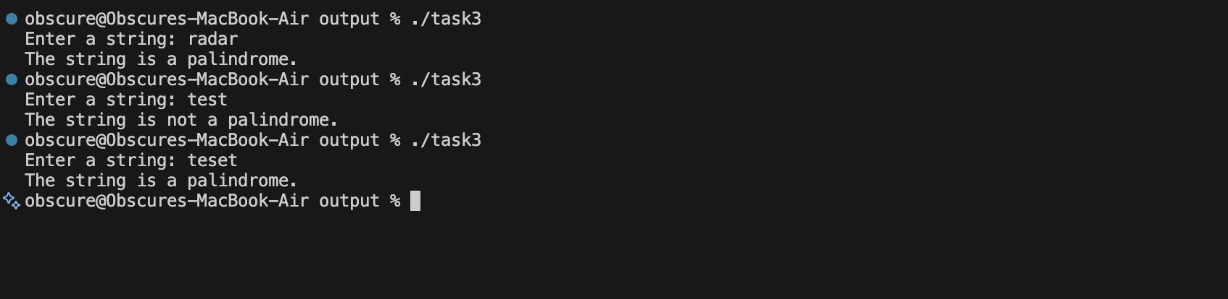

Task 4 [CLO 3]:

CODE:
#include <iostream>

int uniquePaths(int m, int n)
{
// base case: if we reach the last row or last column, there's only one path
if (m == 1 || n == 1)
return 1;

// recursive case: sum of paths from the cell to the right and the cell below
return uniquePaths(m - 1, n) + uniquePaths(m, n - 1);
}

int main()
{
int m, n;
std::cout << "Enter grid dimensions (m n): ";
std::cin >> m >> n;

int paths = uniquePaths(m, n);
std::cout << "Number of unique paths: " << paths << "\n";

return 0;
}

OUTPUT:
